状态转移图：
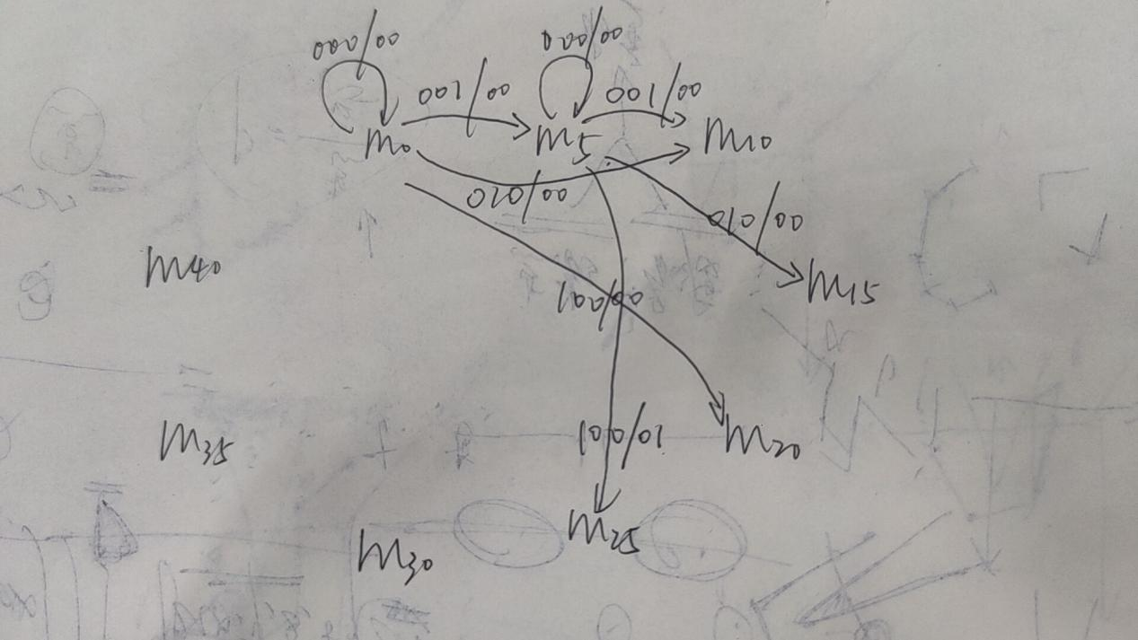
状态机部分代码：
case current_state is
when m0=>
output_ticket<='0';
return_money<="000";
case input_money is
when"000"=>next_state<=m0;
when"001"=>next_state<=m5;
when"010"=>next_state<=m10;
when"100"=>next_state<=m20;
when others=>next_state<=current_state;
end case;
完整代码：
library IEEE;
use IEEE.STD_LOGIC_1164.ALL;

entity ticket_state_machine is
Port (
clk,reset:in std_logic;
input_money:in std_logic_vector(2 downto 0);
return_money:out std_logic_vector(2 downto 0);
output_ticket:out std_logic
);
end ticket_state_machine;

architecture Behavioral of ticket_state_machine is
type states is (m0,m5,m10,m15,m20,m25,m30,m35,m40);
signal current_state,next_state:states;
begin

start:process(reset,clk)
begin
if(reset='1')then
current_state<=m0;
elsif(reset='0'and clk='1'and clk'event)then
current_state<=next_state;
end if;
end process;

state_machine:process(current_state,input_money)
begin
case current_state is
when m0=>
output_ticket<='0';
return_money<="000";
case input_money is
when"000"=>next_state<=m0;
when"001"=>next_state<=m5;
when"010"=>next_state<=m10;
when"100"=>next_state<=m20;
when others=>next_state<=current_state;
end case;
when m5=>
output_ticket<='0';
return_money<="000";
case input_money is
when"000"=>next_state<=m5;
when"001"=>next_state<=m10;
when"010"=>next_state<=m15;
when"100"=>next_state<=m25;
when others=>next_state<=current_state;
end case;
when m10=>
output_ticket<='0';
return_money<="000";
case input_money is
when"000"=>next_state<=m10;
when"001"=>next_state<=m15;
when"010"=>next_state<=m20;
when"100"=>next_state<=m30;
when others=>next_state<=current_state;
end case;
when m15=>
output_ticket<='0';
return_money<="000";
case input_money is
when"000"=>next_state<=m15;
when"001"=>next_state<=m20;
when"010"=>next_state<=m25;
when"100"=>next_state<=m35;
when others=>next_state<=current_state;
end case;
when m20=>
output_ticket<='0';
return_money<="000";
case input_money is
when"000"=>next_state<=m20;
when"001"=>next_state<=m25;
when"010"=>next_state<=m30;
when"100"=>next_state<=m40;
when others=>next_state<=current_state;
end case;
when m25=>
output_ticket<='1';
return_money<="000";
case input_money is
when"000"=>next_state<=m0;
when"001"=>next_state<=m5;
when"010"=>next_state<=m10;
when"100"=>next_state<=m20;
when others=>next_state<=current_state;
end case;
when m30=>
output_ticket<='1';
return_money<="001";
case input_money is
when"000"=>next_state<=m0;
when"001"=>next_state<=m5;
when"010"=>next_state<=m10;
when"100"=>next_state<=m20;
when others=>next_state<=current_state;
end case;
when m35=>
output_ticket<='1';
return_money<="010";
case input_money is
when"000"=>next_state<=m0;
when"001"=>next_state<=m5;
when"010"=>next_state<=m10;
when"100"=>next_state<=m20;
when others=>next_state<=current_state;
end case;
when m40=>
output_ticket<='1';
return_money<="011";
case input_money is
when"000"=>next_state<=m0;
when"001"=>next_state<=m5;
when"010"=>next_state<=m10;
when"100"=>next_state<=m20;
when others=>next_state<=current_state;
end case;
end case;
end process;

end Behavioral;

